Pandas Project

Course Name: Pandas Project
Course Resource: Materials + practical business case study + PPTs + FAQs + Data
Course Content: Given Below

Case Study from Retail domain (3 to 4 Hrs)

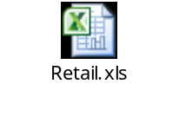
- Problem statement
- Dataset explanation
- Data Management for Retail dataset using Pandas. It includes:
- Reading Retail data files
- Sub setting the data frames
- Aggregation of Sales and other important measures
- Identify the best products in terms of Sales and Visits
- Feature engineering using Retail dataset
- Sorting, Merging etc. using Retail dataset.
- Data Analytics for Numerical measures (Sales, Inventory, Stores and so on)
- Descriptive statistics
- Univariate Statistics and so on
- Data Visualization to identify possible trends across products, region and so on
- Visualization or graphs using Retail dataset.

